Software design document:
Locus algorithm:
Version 2.1 (Changes from version 2.0 are highlighted in italics)
7th July 2008

Inputs: filtered_file.fit file (changed due to an error)
Output: target_point.fit

This document describes the simplified locus algorithm which searched for a point that can be used as a centre of FoV to catch the maximum number of stars in the FoV with it. The program reads in a filtered list produced by an earlier stage of the program, determines a locus of points where a FoV can be centred for each star and then determines the intersections between the boundaries of these intersections: the points at which the value of an area changes value.

Step one: read filtered catalogue into memory

- Open FITS file internal_fits
- Dynamically allocate memory to hold this data (array of struct star) internal_array
- Read catalogue entries into allocated memory. See Error: Reference source not found for a pictorial representation

Step two: for each star determine its boundaries
- For each star, its bounding RA and Dec are described by a single point determined by adding the radius to stars below the target and subtracting the radius from stars above the target in each direction.
- The boundaries also must have a direction designated for them: from the bounding point, the direction is “1” for stars above the target and “0” for stars below the target (in terms of RA or Dec value). These are designated by a bool variable.
- Error: Reference source not found shows how these boundaries would appear on the star field,
Step three: determine the intersections with other boundaries
- The boundaries will intersect at two, one or no points as determined by the position and alignment of the bounding lines. for any given pair of stars being considered.
- Figure 2 shows a these intersections highlighted.
- Lines which intersect designate a point which is passed to later steps in the algorithm.
- Lines which do not intersect at all will be removed from consideration.
Step four: count the score for each intersection.
- For each intersection point, check which of the stars would be able to use it as a central target point.
- Count these stars. Check this count against the best target so far. In later versions this crude count will be replaced by a scoring system.
- If the current intersection is now the best target, place it into the “Best” variable.
Step five: Cycle the algorithm through all possible intersections
- Repeat steps three and four for each intersection and produce a final target (an intersection) and a rating for this.
- Figure 3 shows the results of this process. Note that while each intersection has been given a score, only the “best” point will be located in memory.
Step six: Write the entry to a catalogue
- Open a fits file, (new or existing?) and write the Position and Magnitude of the target object, the position of the target point and the number of stars still in the field.
Figure 1: Software design diagram
main
read
filtered_file.fit
gets number of rows
for all rows
gets details of each entry
Number of Rows
Array of struct star
write
Adds the position of the target object and target point to a fits file
Final output file.fit
boundary
for all rows
Puts boundaries on each entry
Array of struct bounded_star
get_intersection
for all boundary_ra
for all boundary_dec
finds the intersection
check_intersection
for all stars
counts if star is in range
if score is highest
Best intersection
Current intersection

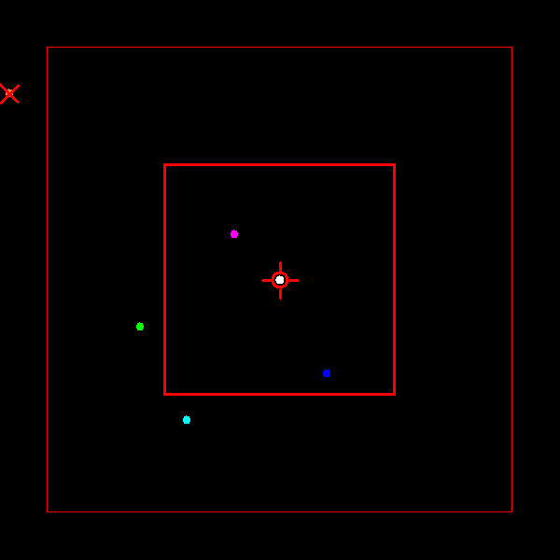
Figure 2: filtered star field

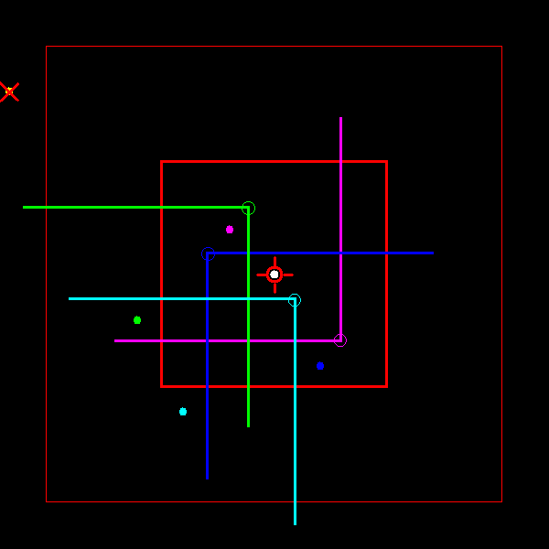
Figure 3: Bounded stars

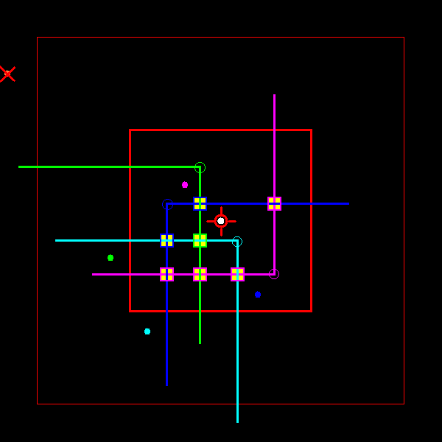
Figure 2: Intersection points selected

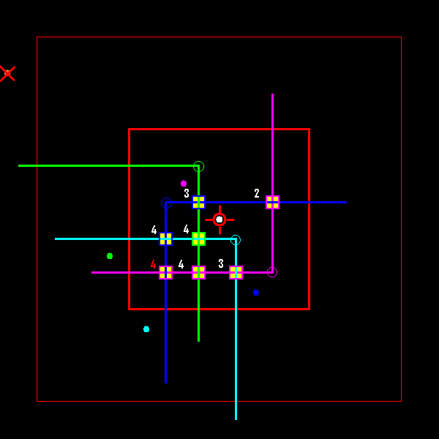
Figure 3: Intersection points rated and best highlighted in red

